Jacqueline Coates

CPSC 430

Usability Study

March 19, 2019

1. Overview of System Functionality
   1. The users will be Professor Gusty Cooper, students in Cooper’s class, and any other internet user. Students would come to the website to read Cooper’s biking blogs and to access class assignment on Mooshak. If a student is in Cooper’s class then they will have to log in to access Mooshak. A nonstudent will be able to read blogs, but will not have access to Mooshak. Cooper would use the website to create, edit, and post blogs.
2. Imaginary Users
   1. Sally is a freshman in Gusty Cooper’s Intro to Computer Science class. Trying to learn more about her assignment, Sally goes to Cooper’s website to check it out. Before going to Mooshak, Sally looks around the website to the biking page. She skims through Cooper’s biking post, before going to the Mooshak tab. Sally then logs into Mooshak to access the assignment.
   2. Gusty Cooper is the owner of the website and wants to share his most recent biking adventures. Cooper logs into WordPress and goes to the post page. Cooper creates a new post and starts writing down his experience. Once he is done, Cooper adds an image, then clicks the publish button. After posting, Cooper exits out of Wordpress and goes to the Mooshak link. After logging in, Cooper creates a new assignment for his class.
   3. William is not a student or a UMW student. He goe to Gusty.bike to read the latest blog post Cooper has written. William selects the blog tab on the menu to see the latest post. After scrolling through the posts, William goes to the Mooshak tab; he realizes he needs an account to log in and is unable to access the class assignments.
3. User Model
   1. **Gusty.bike is a website with two main functions. The first function is to allow students in Gusty Cooper’s class to access their coding assignments. A student or Cooper will go to Gusty.bike and click on the Mooshak tab in the menu bar. They will then login to Mooshak, then submit and view assignments Cooper has created. Only students and Cooper will be able to access Mooshak. The second function is the blog function. Everyone is able to view the blog, but only Cooper will be able to create and edit blogs. This site will be run by Wordpress, which will allow Cooper to run the back end of things. Cooper will also be able to post pictures and PDF on posts and pages. Each function will fall under Gusty.bike website, so it is in one location for students and Cooper to use.**
4. Image Prototype
   1. This image is of the front cover of the website, which has a picture of Gusty Cooper and his websites name.

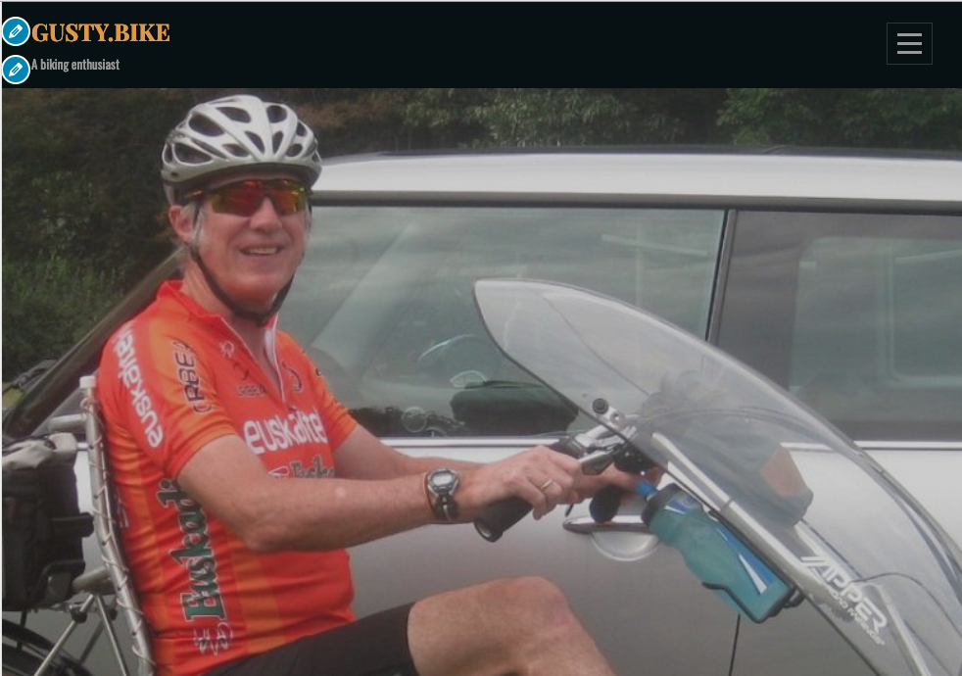

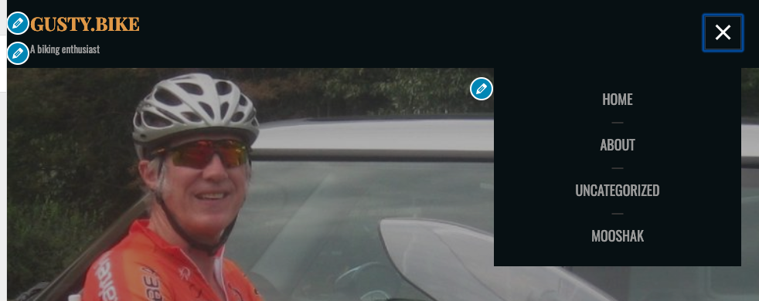

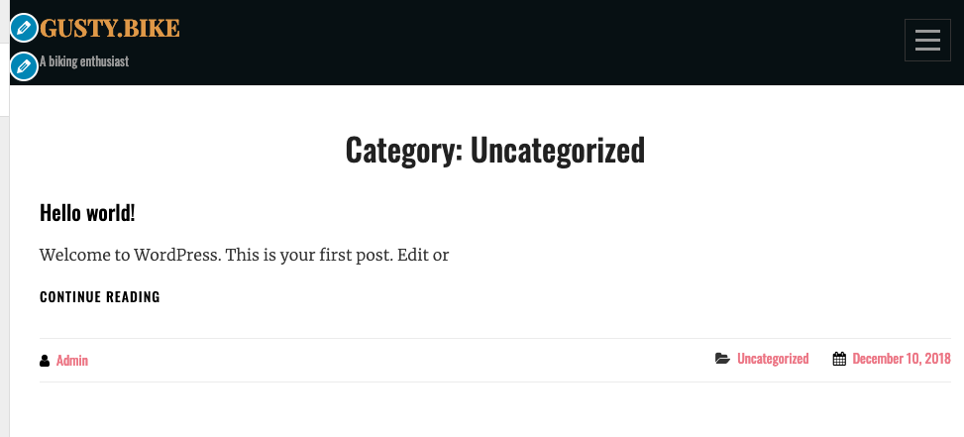

1. Focus Group Feedback
   1. Focus Group People
      1. Abby Brock Comments
         1. “why is it called Gusty.bike”
         2. “what is Mooshak?”
         3. “ So basically you have a blog.”
         4. Abby identified that Wordpress was the backend of the site.
      2. Jillian Gellman Comments
         1. “It’s just a WordPress site for his biking class”
         2. “This is for the students to learn more about Cooper”
         3. “Its a blog site”
         4. “a student shouldn’t be able to post, but Cooper can”
      3. Katie -
         1. “ if they are a student they can log into Mooshak”
         2. “students can view the blog but not post”
         3. “Cooper can go behind the scene”
         4. “students can view blog”
         5. “Everyone else can view but not go into Mooshak”
   2. Feedback
      1. Based on the feedback, most of the students understood the blog portion, but not Mooshak. They knew that Mooshak was a system that only student and Cooper could access and you, but they didn’t know what it did. So for the changes, I will be adding more details about Mooshak.
2. Changes
   1. Gusty.bike is a website that is owned and run by our Client Gusty Cooper; There are two main functions to this site; The first is to host blogs and the second is to post coding assignments. Blogs will be managed and edited using Wordpress while the server will be an AWS(Amazon Web Services) instance. The blogs will allow anyone in to see Cooper’s biking hobby. Everyone is able to view the blog, but only Cooper will be able to create and edit blogs. His blogging site will have a tab to access Mooshak, which is an internet interface that host coding assignments. Cooper and his students will be the only ones to log in to Mooshak. Cooper will create an assignment while the student will be able to view and submit assignments.